Year 6 Home Learning w/b 11-01-21

Dear children,
We hope you all had a good weekend. Here is this week’s work. Do try to complete as much of it as you can and remember to email us how you are doing and anything you finish to year6@st-james.dudley.sch.uk. Remember to keep your war diary work safe to bring back into school when we return!
Keep safe,
Year 6 staff

Contents:
Date: | Lessons:
Monday 11th January | Maths:  To multiply decimals video lesson worksheet answers  Extra practice Power Maths Book B p21  English:  Spellings Spring 6  To explore the functions of fronted adverbials  https://classroom.thenational.academy/lessons/to-explore-the-functions-of-fronted-adverbials-6cu3ar  To revise the past, present and future progressive tense  https://classroom.thenational.academy/lessons/to-revise-the-past-present-and-future-progressive-tense-6rukjd  Reading:  To make inferences about characters in the book (Part 1)  https://classroom.thenational.academy/lessons/to-make-inferences-about-characters-in-the-book-part-1-c4tp6t  PE:  PE with Joe Wickes  https://www.youtube.com/watch?v=BDigyoBrHms&list=PLyCLoPd4VxBsYwx1a3RXMoAuJp1MAVG_O  Catch up English:  To explore relative pronouns  https://classroom.thenational.academy/lessons/to-explore-relative-pronouns-74v62c
Tuesday 12th January | Maths:  To divide decimals video lesson worksheet answers  Extra practice Power Maths Book B p27  English:  To gather information on an inspirational figure  https://classroom.thenational.academy/lessons/to-gather-information-on-an-inspirational-figure-74u68d  Reading:  To make inferences about characters in the book (Part 2)  https://classroom.thenational.academy/lessons/to-make-inferences-about-characters-in-the-book-part-2-6gt3gd  Comprehension – Winston Churchill  PE:  PE with Joe Wickes  https://www.youtube.com/watch?v=Y2AkYD10d7Q  Music:  Have a go at learning some of these songs from the war.  https://www.youtube.com/watch?v=EsSCpetPNFM
Wednesday 13th January | Maths:  Fractions to decimals 2 video lesson worksheet answers  English:  To develop a rich understanding of words associated with being hard –working  https://classroom.thenational.academy/lessons/to-develop-a-rich-understanding-of-words-associated-with-with-being-hard-working-65gkcc  Reading:  To consider a character's perspective and themes within a text  https://classroom.thenational.academy/lessons/to-consider-a-characters-perspective-and-themes-within-a-text-cmr3ar  Comprehension: - David Walliams  Catch up maths:  2D and 3D shape: To identify, describe and classify shapes based on the properties (Part 1)  https://classroom.thenational.academy/lessons/2d-and-3d-shape-to-identify-describe-and-classify-shapes-based-on-the-properties-part-1-6dhpac  RE/PSHE:  To recognise roles and responsibilities in a community  https://classroom.thenational.academy/lessons/i-roll-with-my-role-65h3gr
Thursday 14th January | Maths:  Division to solve problems video lesson worksheet answers  English:  To plan a biography  https://classroom.thenational.academy/lessons/to-plan-a-biography-c8wp6d  Reading:  Comprehension – JK Rowling  Catch up maths:  2D and 3D shape: To identify, describe and classify shapes based on the properties (Part 2)  https://classroom.thenational.academy/lessons/2d-and-3d-shape-to-identify-describe-and-classify-shapes-based-on-the-properties-part-2-6mrkgt  History:  To understand the evacuation of children during WW2  Watch the first episode of the ‘Children in WW2’ video clip (on the school website). Write the first draft of your letter home.
Friday 15th January | Maths:  Maths Hammer 2  English:  Spelling Test Spring 6  Grammar Hammer 15 https://www.st-james.dudley.sch.uk/grammar-hammer  Reading:  Reading for pleasure - 30 minutes uninterrupted silent reading. Make sure you have filled in your diary for this week in detail.  History:  To understand the evacuation of children during WW2.  Write up your evacuee letter in best for your war diary.

Ongoing extras:
These tasks are ongoing throughout the half term. Have a go at them when you have some free time and work though at your own pace!

Computing – Coding using Scratch: go to: https://scratch.mit.edu/projects/editor/?tutorial=getStarted

At the top, click on ‘Tutorials’ and follow the instructions to learn how to code with Scratch! We can’t wait to see what you can come up with by half term.

Computing – Typing Practice: go to:
https://www.bbc.co.uk/bitesize/topics/zf2f9j6/articles/z3c6tfr

Start at level one and work your way through the typing activities. You’ll be touch typing in no time!

Music – WW2 songs
Have a go at learning some of these WW2 songs. If you are brave enough to film yourself and send it to us, that would be great!
https://www.youtube.com/watch?v=EsSCpetPNFM

Monday 11th January – Spellings Learn for Friday please
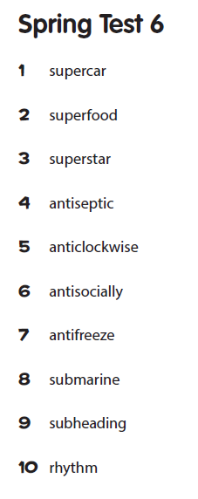
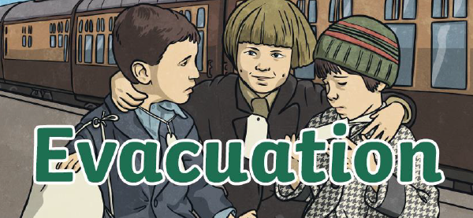
Thursday 14th January – history

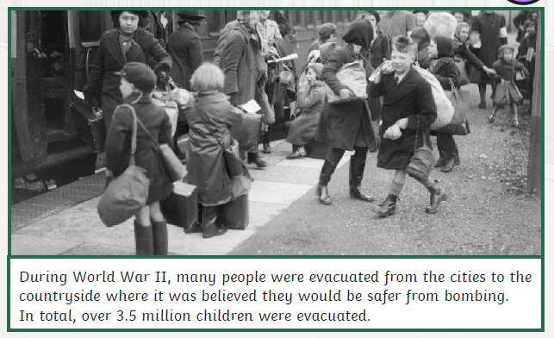

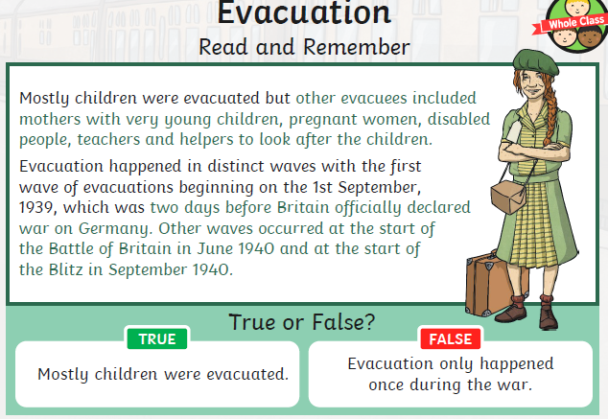

Thursday 14th January – history
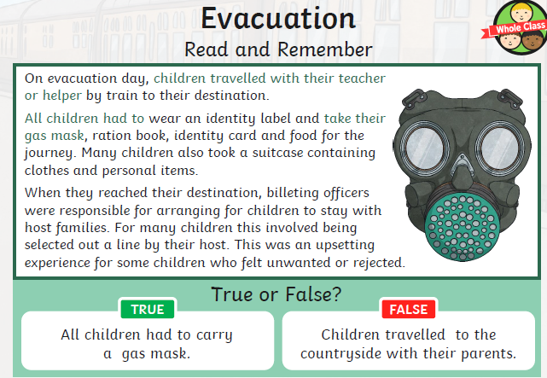

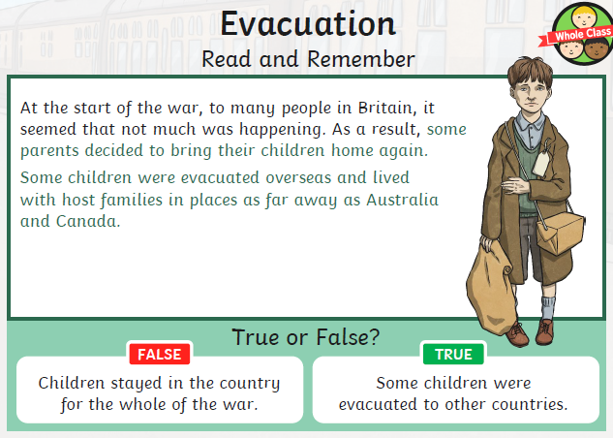

Thursday 14th January – history

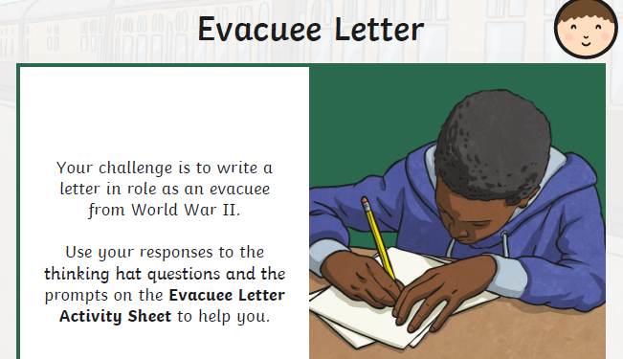
Write a rough draft of the letter today and write it up in best tomorrow afternoon ready to go in your war diary.
Have a look at an example from last year to help you.
Remember to write using your war name you picked the other day.

Thursday 14th January – history
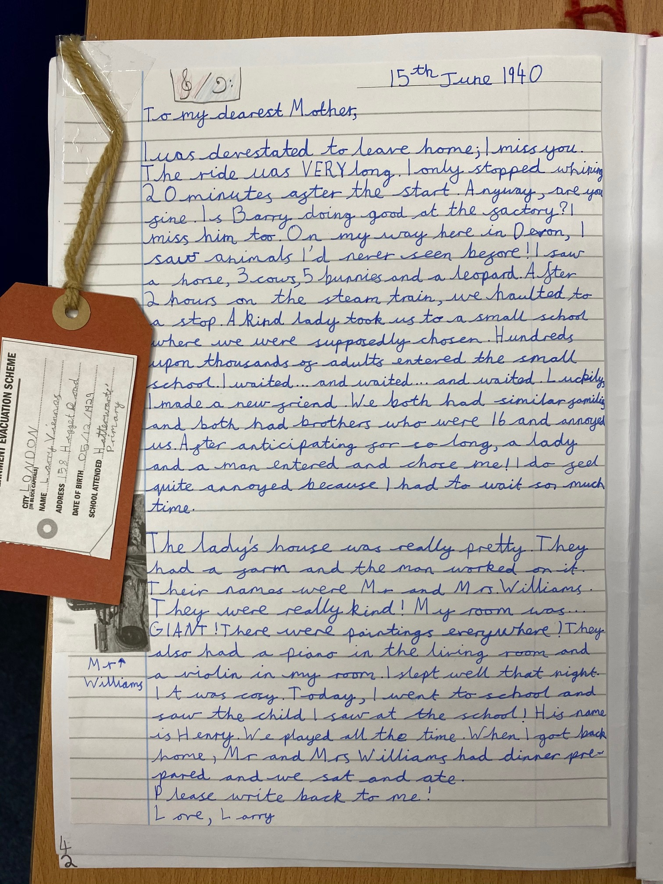
Friday 15th January – Maths Hammer

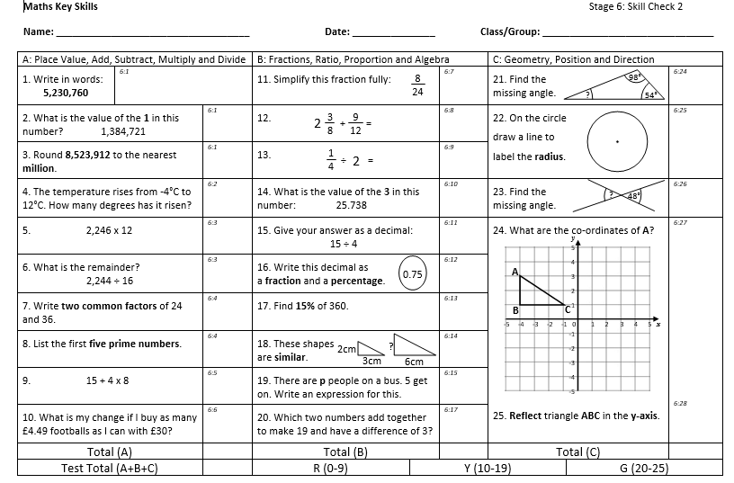
Friday 15th January – Maths Hammer

Friday 15th January – Maths Hammer

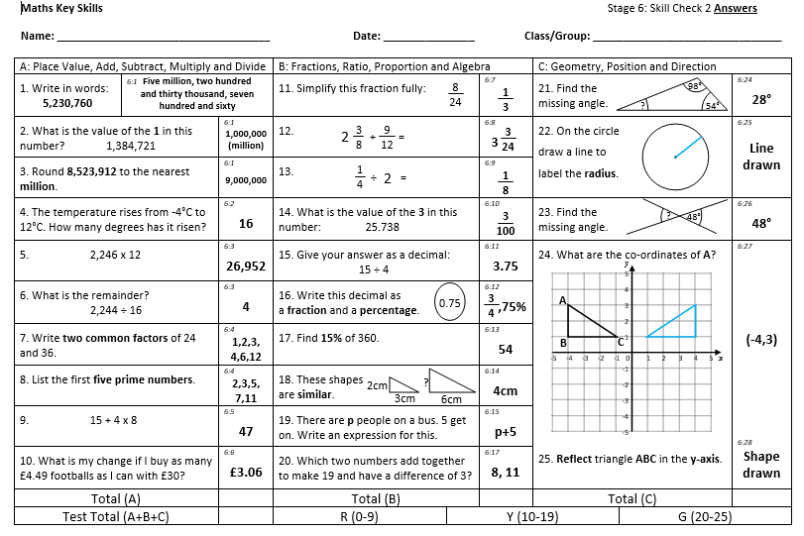

Friday 15th January – Spelling Test
